Nobel Transportation Company

CASE STUDY SUMMARY

NTCo is a domestic trucking company specializing in the transportation of steel.

NTCo was established six years ago by W.Nobel to address the growing need for consistent, reliable steel transportation services between steel manufacturers, distributors, and end-users. The company found huge success due to the owner's knowledge of the trucking industry, strong business acumen and ability to effectively establish and maintain key relationships.

NTCo identified six clear strategic goals during its recent strategic planning session including:
1. Leverage corporate reputation and brand recognition to expand current transportation services in new markets by 50% by Q3.
2. Introduce new transportation service offering to capitalize on green and clean energy construction markets.
3. Increase customer retention and set "best in class" customer service standards.
4. Continuously broaden customer database by obtaining new information on consumer characteristics and needs.
5. Increase efficiencies through the use of wireless or virtual technology.
6. Increase charitable giving opportunities.

ORGANIZATIONAL STRUCTURE

NTCo currently employs 50 full-time and part-time employees. These employees are primarily located in the Midwest United States. The following outlines NTCo's organizational chart.

In addition to its full and part-time employees, NTCo relies heavily on Owner-Operators or truck drivers who own and operate their trucks and are not employees of the company, instead serve as contractors.

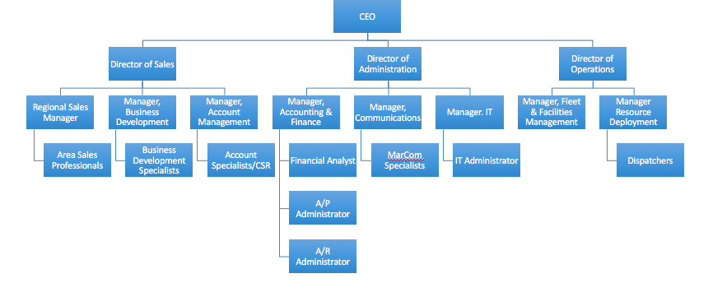

ORGANIZATIONAL CULTURE

Early on when the company had less than ten employees, W. Nobel prided his organization on possessing a "family feel" where everyone knew what to do and knew each other. However, as the business expanded into other states, the organization lost its "family feel" and evolved into more of a corporate environment.

NTCo's culture is one of silos, poor internal communication, minimal accountability, and decentralized supervision. In other words, respective Directors are only concerned with the performance of their department, with little or no regard for other departments. Also, there is notable variation between how one area is run versus the way another is run. Additionally, NTCo's mission statement is vague and ambiguous, "To be the best."

From a human capital perspective, recruitment plan in place, employee feedback is inconsistent and often, employees are not clear on expectations for their job. Employees are not well informed of organizational goals, and there is no clear connection between employee performance and organizational performance.

ORGANIZATIONAL ASSESSMENT

While NTCo has many good attributes such as being a major provider of transportation services, an excellent reputation with customers, has experienced consistent revenue growth since its establishment and has many high performing employees.However, the organization has several areas of opportunity for development. Currently, there is no one person or department overseeing Human Resources functions. The CEO in conjunction with the Director of Administration relies on employee and customer references to identify and acquire talent. While this ideology worked while the organization was small, as the company grows W. Nobel has a concern that there is no HR infrastructure in place.

There are several tools in place as a result of a previous consulting engagement such as job descriptions and a compensation structure.Nevertheless, there is little else existing to address the employee lifecycle (on-boarding, through flow, and off-boarding). The company does not have a human resources manager and most of the HR functions are outsourced.

Due to the absence of a role to focus on human resources, as well as the absence of an employee evaluation tool, supervisors do not know exactly what to do about several employees who according to the supervisor, "just isn't hitting the mark."

ASSIGNMENT

NTCo has hired you as an HR Consultant to assist in identifying a realistic plan to address several issues. NTCo is asking that you develop a comprehensive action plan and plan tools inclusive of:

Development of a performance appraisal tool (Module 2).

Development of a developmental plan to create a competitive workforce (Module 3).

Development of a Performance Improvement Plan (PIP) for low-performing employees utilizing a 6-step model (Module 4)

Create a paper and PowerPoint presentation action plan addressing the workforce issues facing the company (Module 5).

